

**Whitepaper**

[**Chapter 1: Rights Overview** 3](#_Toc527478829)

[Section 1:　Rights Definition 3](#_Toc527478830)

[Section 2: Transforming Content World 5](#_Toc527478831)

[Section 3: Rights Implementation 5](#_Toc527478832)

[**Chapter 2: Potential Market of Rights** 7](#_Toc527478833)

[Section 1: Artist Market 7](#_Toc527478834)

[Section 2: VR/AR Character Market 9](#_Toc527478835)

[Section 3: Consumer In VR Space Market 10](#_Toc527478836)

[**Chapter 3: Eco System** 12](#_Toc527478837)

[Section 1: E-money And Original Digital Points 12](#_Toc527478838)

[Section 2: Purchasing Rights Cryptocurrencies And Event Participation Rights 13](#_Toc527478839)

[**Chapter 4: Growth Scenario** 15](#_Toc527478840)

[Section 1: Growth Scenario Concept 15](#_Toc527478841)

[Section 2: Organic Growth Measure 15](#_Toc527478842)

[Section 3: In-Organic Growth Policy 16](#_Toc527478843)

[Section 4: Risks And Challenges 17](#_Toc527478844)

[**Chapter 5 System Roadmap** 18](#_Toc527478845)

[Section 1: Rights Distributed Digital Network Development Schedule 18](#_Toc527478846)

[**Chapter 6 Team** 19](#_Toc527478847)

[Section 1 :Developing Team Introduction 19](#_Toc527478848)

[**Chapter 7: Conclusion** 23](#_Toc527478849)

[Change History 25](#_Toc527478850)

# **Chapter 1: Rights Overview**

## Section 1:　Rights Definition

**Rights - New Dimension of Media Market in digital space**

**「Guaranteeing proof of real-exist digital contents」**

Ownership data of digital contents distributed on Rights Distributed Digital Network (RDDN) will be engraved on Blockchain. Currently unable-to-exceed data ranges such as images, audios, videos will be certainly changed to users specialized assets. Consequently, digital contents will be reborn and distributed as real-exist digital assets.

Visualization of digital assets & owners, issuers data

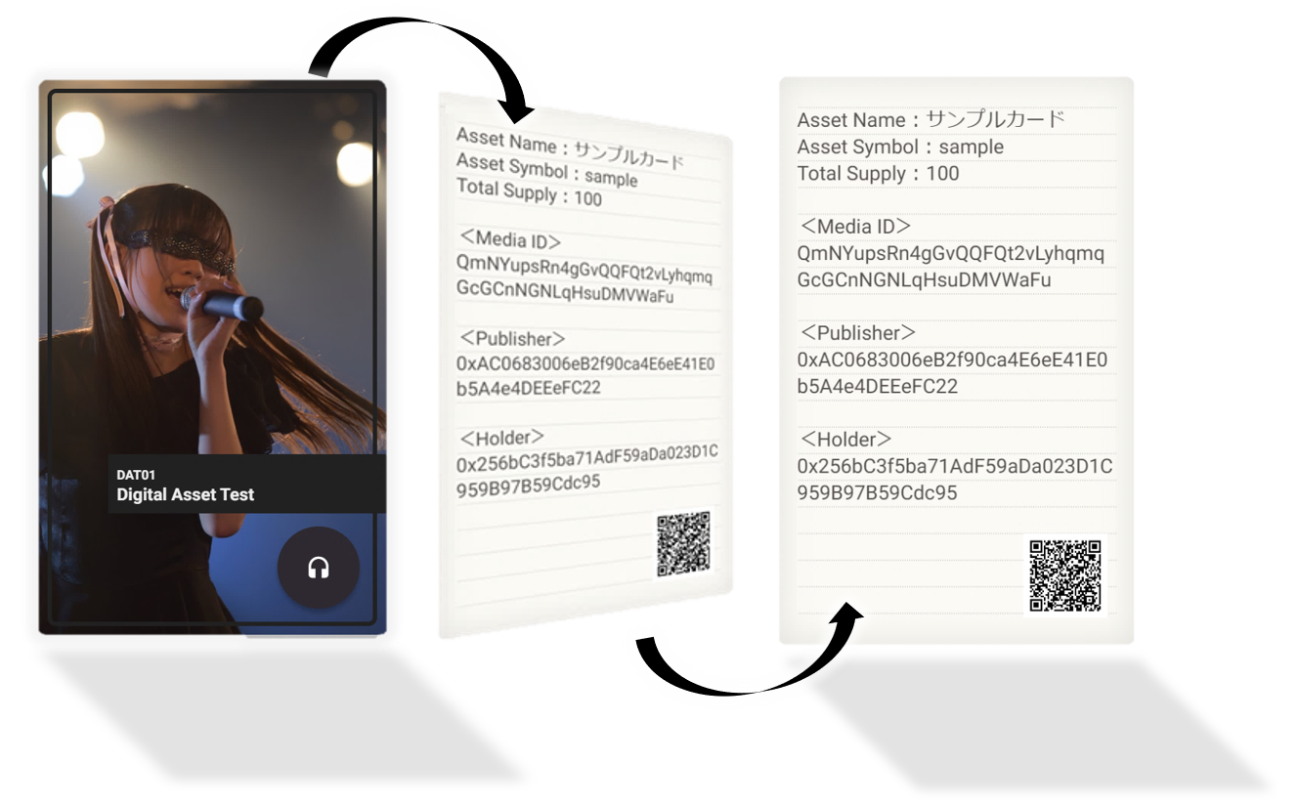

**「Providing a space for selling digital contents to all content holders」**

Rights acts as an open environment to all content holders. Digital contents are created and duplicated easily even in small amount of budget. Consequently, small-scale contents can be distributed on Rights, making profit.

**「Suppress fraudulent distribution」**

　 Once written on Blockchain, data of digital content owners will be immutable. By deploying digital watermark (information hiding techniques), owner information will be embedded in digital contents. Assuming illegal distribution on a network outside Rights, based upon Blockchain solid basis, the original source is easily to be traced back.

**「A meeting-talking space with artists」**

Rights creates socializing space connects artists and fans. Moreover, artists able to perform fan services regardless of time and place. Herein, a novel project to bring artists closer to fans (digital supporting screening etc.) to be implemented, fans therefore understand artists deeper, giving more supports. Deploying real-time chat communication with artist in that space will require a small service charge.

Plus, the mentioned chart will be under analysis by AI to provide both artists and fans a secured space.

Moreover, along with advances from Virtual Reality (hereinafter refers as VR), and Augmented Reality (hereinafter refers as AR), Rights will become a lifelike space with artists beside fans.

**「Community heat meter, fascinating new fans」**

　RDDN is able to convey the excitement of entire community. Rights contains points exclusive for artists which granted according to the contribution such as digital contents purchasing. This distribution volume will be measured and converted as community quantitatively value.

With each community value graphically be shown. Users can intuitively glimpse at artist-fan dynamics. Which likely drives their new interests.

Furthermore, not only the community heat is displayable, community growth rate will be also represented by means of visual image. Therefore, a small-scale community can equally stand a chance to attract attention as a high-growth community. Further, these quantified values based on artist’s points will be recorded on Blockchain.

Image of diagram 「Heat value」 by artists

The circle size indicates the heat value magnitude

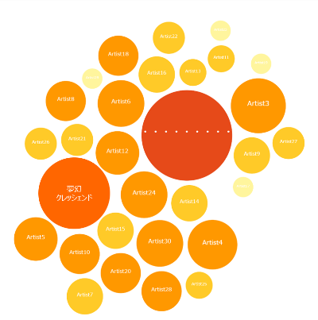

**「“Right event” kickoff to enhance community heat」**

　Rights provides the experiences beyond the boundaries of individual communities through events organized both in digital network and real world to all artists and fans. Each artist will be offered with spotlighted stages through various event classifications as top artist selection, live battles etc. Those events will be acknowledged by event participation purchased by fans in a crowdfunding format.

Thus, new stars are raised, new entertainment sprouts. Event participation rights can be acquired by dedicated cryptocurrencies.

**「Regular Rights live supporting joining artists」**

Artists win most shining moments on stages. Therefore, Rights will hold regular live concerts focusing mainly on joining artists as in-real support activities. RDDN non-participators also able to be supported in live concerts. But for continuous sustainability, Rights participation remains a necessary condition. Thus, for example, newly starting artists looking for supports and Rights increasing participants (network expansion) will be consistent, forming a win-win relationship.

## Section 2: Transforming Content World

This section demonstrates the changing trend in content world, as RDDN’s birth background. The fifth generation (5G) community technology is expected to be in practice from 2020, along with evolution of ultra-highly resolution displays and acceleration of VR/AR displays promise soon-to-be-born mixed contents.

Us, currently living in the middle of dynamic changing era.

**Age of new contents**

Possible to connect more than tens thousands time faster, more simultaneous

Thanks to VR/AR technology innovation

Digital world and real world’s border getting ambiguous

*「VR will soon disappear」*

*「Since even using is commonplace」*

「way to create future 2020-2045　～I bet on VR～by　GOROman」

Human beings can sometimes enjoy adventurous trips  
 likewise using magic, monster fights…  
and fellowships which unavailable in real-world

That said adults don’t play video games. But what if they find themselves in their own dreamy journey in digital world? Rights eventually will become the infrastructure of that world.

## Section 3: Rights Implementation

If the boundary between the physical world and the real-world blurs, or in other words, if the digital world is almost equal to the reality. Users digital assets should be under protection. Rights realizes that status.

By protecting user assets damages namely value dilution, illegal copying…Therefore removing related anxiety, designers and users will be able to utilize dream-like digital world safely, securely.  
This section shows Rights-based safe and secure services.

**「Sorting favorite cards, showing to friends」**



（Digital assets distribution）

**「Digital monster fights」**



（Weapon distribution）

**「Digital inhabit with friends」**

****

（Companion communication, fashion items distribution）

# **Chapter 2: Potential Market of Rights**

This chapter describes Rights potential market size of “New Dimension Media Market”.

Assuming there are 3 user types in 「New Dimension Media Market」

Firstly: artist market. Secondly: character market-mainly for manga and animation. Lastly: consumers market. Those 3 mentioned above markets are Rights use-case targets. In conclusion, Rights is a new dimension media markets for artists, character, and consumers.

Following sections will explain each of potential market size

## Section 1: Artist Market

**Potential market size: 200 billion JPY**

First of all, Rights 「New Dimension Media Market」 has set initial theme as artist market, relates to Otaku market, which continuously increases in popularity over the world. Furthermore, Rights focuses on deepening, designing services for idol markets with Japanese biggest geek market. In addition to the fast-grow rate of Japanese Indie Idol market (live performance by small scale, large number of Idol units, generally called “underground idols” in Japan). As can be seen, this market plays the role of background stage creating opportunities to young generation.

Japanese idol market annual sales reached 210 billion JPY in 2017, keeps growing 10%/year（Source：Yano Economic Research Institute <https://www.yano.co.jp/press/press.php/001773>）

Based on 2017 market growth records and trends, this project includes Japanese idol market future growth prediction.

Presuming current trends to continue, market size will reach 270 billion JPY in 2025.

　　　　　　　（Unit：Billion JPY）

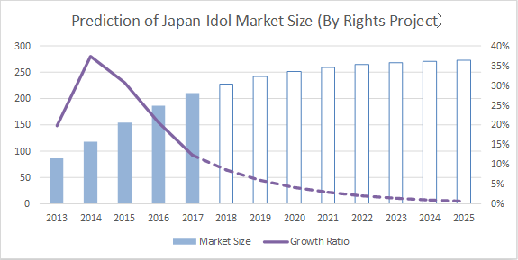

Japanese idols market had maintained a high growth rate at 10%/year in 2017, and witnessed a decrease since 2014, followed by a downward trend and it will be gradually moving to the low growing pace. As the result, growth rate will attain approximately 1%/year around 2023. However, still a promising market which is expected to have growth room of 60 billion JPY.

Regards to this market growth, Rights will provide market services based on digital assets, digital communication as centerpieces. Hereunder table will illustrate current music market by sale:

Japanese music industry sale composition in 2016（Source：Rakuten securities）

|  |  |  |
| --- | --- | --- |
| Category | Sales  (Million JPY) | Ratio |
| Concert / Live Performance | 310,078 | 51% |
| Music Software | 245,657 | 40% |
| Online Music Distribution | 52,886 | 9% |
| Summary | 608,621 | 100% |

Japanese music industry sales trend (unit: million yen)

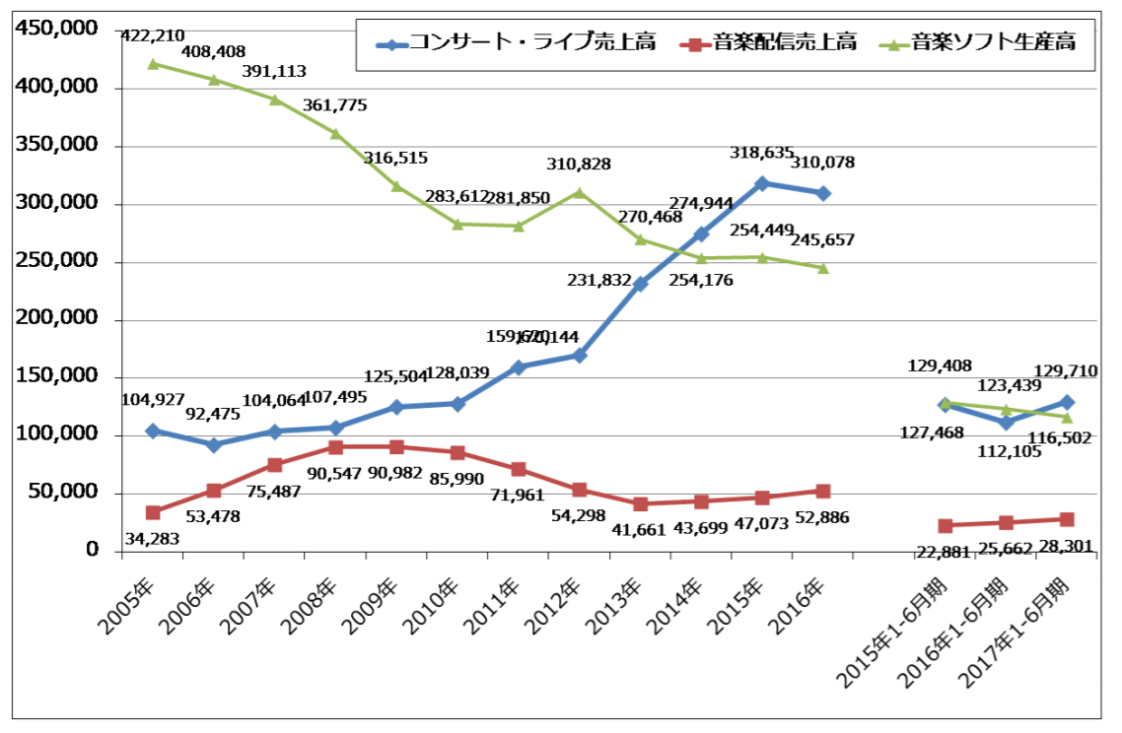

Source：Rakuten securities　<https://media.rakuten-sec.net/articles/print/11557>  
(Blue: live, concerts sale. Red: music distribution sales. Green: music software products)

Unlike other music markets, Indie market (Rights initial main target) saw a significant sale ratio by special services such as handshake tickets or item sales. Although market remains facultative to apply, this material estimates the reference value of potential market size using the data.

From 2016 to 2017, live concert grew for 50% of the total sales with the growth rate has slowed.

On the other hand, sales in music software is steadily decreasing. Conversely, there is an upwards trend in music distribution sales. Assuming those trends continue, live sales will be stable around 50% of total. Share in music software production sales will stand half comparing to current state. The table below demonstrates the case, assuming rising online service.

Japanese music market sales Breakdown Forecast (2025)

|  |  |
| --- | --- |
| Category | Ratio |
| Concert / Live Performance | 51% |
| Music Software | 20% |
| Online Music Services | **29%** |

In view of mentioned Japanese idols market in 2025 obtains 270 billion JPY annually with 30% attributes to music online services. Obviously, Rights potential market will possibly reach 80 billion yen (“Music online services” include communication services such as music distribution, money services rather than asset sales likewise digital goods).

Rights will be available both in Japan and entire Asia Pacific. The following will determine market size more specifically when Rights service under deployment throughout Asia, referring Japan and Asia Pacific music market size ratio. Standing 6,5 billion USD as annual sale volume in 2017.   
  
　（Sources：Hexa Research <https://www.hexaresearch.com/research-report/asia-pacific-movies-entertainment-market>）

Japanese music market reached 2,7 billion USD in the same year（Source: Recording Industry Association of Japan <http://www.riaj.or.jp/riaj/open/open-record!file?fid=1638>）

Asia Pacific market is around 2,4 times bigger than Japanese size. By multiplying the mentioned Rights market (80 million yen), 190 billion JPY as the calculate figures

Accordingly, the scale of Rights market can be potentially expected to be over 190 billion JPY.

## Section 2: VR/AR Character Market

**Potential market size estimation: 550 billion JPY**

Rights acts as digital assets in Virtual Reality (VR) and Augment Reality (AR) with Manga, Animation and Vide game characters as themes for artists. The system purposely designed for those domain's assets management and distribution.

Furthermore, in VR/AR Manga, Animation and Vide Game Characters will be more active in the future, anticipating Artificial Intelligence-based services contribute magnificent progresses. Rights aims at development integration with those extended services.

Once development integration successes, Rights will function as a social life foundation with animated characters in the VR/AR world.

Japanese animation annual sales volume reached 2 trillion JPY in 2016. Animation item sales is predicted to exceed 500 billion JPY （Source：Cinema Today　<https://www.cinematoday.jp/news/N0095751>）

According to Japan Animation Association report released in January 2018, animation items stagnated around 500-600 billion JPY in a long period, meanwhile digital items stayed on an upwards trend (Source: <http://aja.gr.jp/?wpdmdl=1202>) It can be said that animation character business is shifting to digital.

Character business stagnation and online distribution growth (unit: billion yen)



Character products business stagnates meanwhile online distribution steadily grows. Hence, digital commercialization will highly advance much more. In this project, at least 20-30% considered to be digitized. With that portion, the potential market size stands at 150 billion JPY.

（Reference）According to National Publishing Association（[Source：https://www.ajpea.or.jp/information/20180125/index.html](file:///C:\Users\Koji%20Machi\AppData\Local\Temp\Source：https:\www.ajpea.or.jp\information\20180125\index.html)）Japan’s 2017 publishing market valued 1.5 trillion JPY. E-book amounted 221 billion JPY, 14% in total. As recent trend, annually 2-3% has been replaced by electronic books, and paper media got digitalized in all industry.

Market size and growth rate of Japanese electronic publication market (unit: billion yen)



Besides, Rights will entry Chinese market. The Comics and Animations markets are expanding quickly recently (hereinafter refers as Dòngmàn market), character items business values 40 billion CNY (1 CNY= 17 JPY, equivalently 680 billion JPY), by far Asia largest market.

If 30% of the mentioned Japanese market gets digitized. Simply calculated, Rights might reach 200-billion-yen potential market. In addition, Chinese Animation market grows at 50% annual rate recently. Even with slower pace, market size is likely to double in volume. Assuming double scale, the potential market can overtake 400 billion JPY.

## Section 3: Consumer In VR Space Market

**Potential market size: 1 trillion JPY**

In recent years, people has been paying greater attraction to game experiences in VR space and use of applications due to low-price VR devices such as PlayStation and Oculus Go. Plus, standalone head-mounted VR devices namely Oculus Go and Mirage Solo released in 2018 show the possibility of making VR services user-friendlier.

The noteworthy point of “easy-to-use VR devices” such as Oculus Go lies in the ability of movie viewing and conference holding, in addition to conventional games. If the user review Oculus Go, comments encouraging video players (such as Netfix) overflow. Furthermore, by utilizing Oculus Room as a new VR application, users can enjoy conversations in private rooms.

These indicates within a short time, VR will possibly spread into life with greater uses in various places from geeks, gadget toys. As in 2018, can’t say there is small amount of problems (display low resolution, tired after head-mounted long use, yet-to-be refined applications etc.) But under continuous improvements, devices and applications are expected to breakthrough.

Such VR/AR world will soon to be attracted with avatar fashion (user projects his own characters in VR world). In case users enjoy watching movies and having talks with friends. Simply, in the extension line, a date with your lover or a party gathering people will appear. When spending living time in VR space, people will demand for fashion items as the way to express themselves. Thus, in VR future space, fashion items likewise clothing, accessories to be sold and distributed.

However, if these original items can easily be forged or faked in VR Space, their prices will drop considerably and unable to grow up high brand designers in the market. For that reason, Rights utilizing Blockchain technology as the measure to guarantee item creators, purchasers. In other words, Rights functions as fashion item guarantee system in VR space.

Despite not the latest news, fashion market exceeded 80 trillion JPY in major Asian countries in 2013 (Source: Ministry of Economy, Trade and Industry http://www.meti.go.jp/policy/mono\_info\_service/mono/creative/fashion\_gyoukyou\_gaiyou.pdf)   
Let’s say 1% over 800-billion-yen fashion sales of these countries to be shifted to avatar VR space. And Asian countries fashion market continue to grow. Naturally, the industry will scale more than 1 trillion JPY. That said, Rights potential market size might exceed 1 trillion JPY.

# **Chapter 3: Eco System**

This chapter will address the Ecosystem of Rights-Distributed Digital Network.

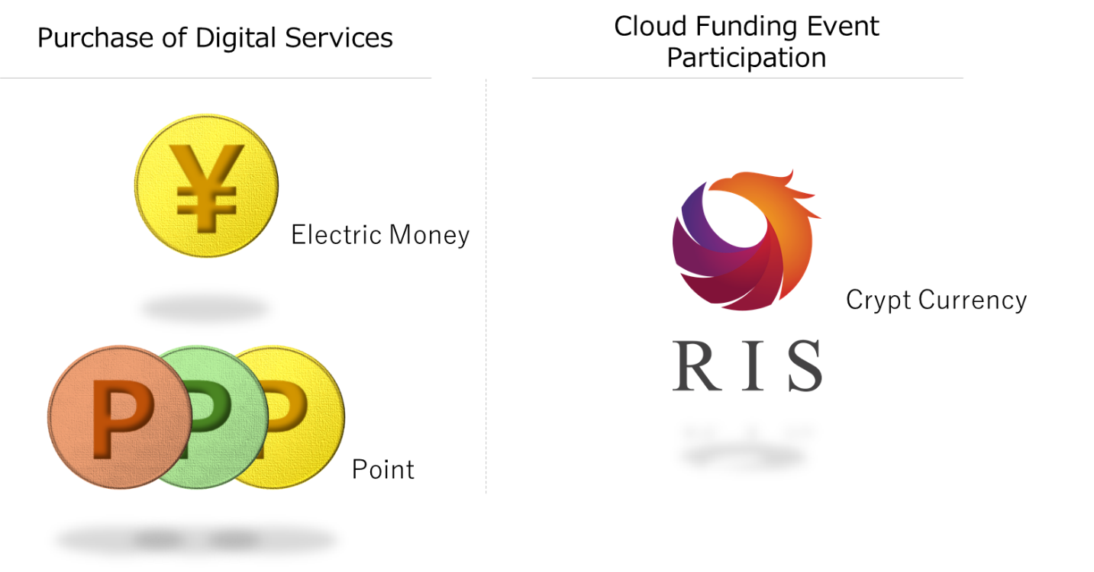

## Section 1: E-money And Original Digital Points

**E-money**

E-money (under laws and regulations of Japan「Prepayment method」) will be issued on RDDN. Users can use E-money purchasing digital contents sold by content holders such as artists (operators). E-money will be issued based on Japanese yen.

The reason behind issuing E-money on Rights network originates from the assume that a considerable proportion of digital assets traded on RDDN will be in a small settlement product around 100 JPY, and system infrastructure enables micropayments needs upgrading. In the future, if banks start to support micropayments by their own virtual currencies or Bitcoin, XRP… Even there is a room to abolish the E-money on RDDN, once services start, only transactions by E-money specialized to Rights are supported.※

Node operators of RDDN are system operators of E-money, transaction fee as income source.

* In countries and regions where legal regulations concerning the use of virtual currency are well developed, priority is given to using RIS which is Rights utility token as the standard currency of digital content purchase

**How to purchase E-money**

Further than possibility of purchasing E-money from virtual currencies like Bitcoin or XRP. Users can settle familiar payment methods such as bank transfer, credit cards.

**Original points issued by content holders**

Additionally, content holders like artists able to issue their own digital points on RDDN, which can be used for customer loyalty management.

Users can earn points as awards when purchasing digital assets on RDDN. Content holders can independently plan, execute point campaigns (However, granting ration is subject to condition that within maximum 20% service/item prices when campaigns are implemented)

The unique digital point of content holders is it can be used only when the point issuer and the digital assets creator is identified to be the same. If not, it won’t be able to be used.

## Section 2: Purchasing Rights Cryptocurrencies And Event Participation Rights

**Event Participating Rights**

There will be various events to be held on RDDN from earliest possible stages after 2019 Spring launching. As mentioned earlier in Chapter 1, numerous events in all shapes in sizes through categories such as top artist selection, live battle etc.

**Cryptocurrencies**

A cryptocurrency will be issued specialized for purchasing participation rights for those events.

(On the premise of resolving regulatory issues, we are also considering the use of cryptcurrency to purchase RDDN digital assets in some countries.) Of which the primary issuing in 2018 Autumn, prior to Pre-sale (official amount is subject to decision in September 2018). No raising of issue limit thereafter.

The number of artists participating in RDDN means related events become bigger and larger. As the result, the total amount of cryptocurrencies in need for voting increase. However, fixed volume enables the cryptocurrency work smoothly under price presume.

However, part of initial issuance total amount will be locked to deposit accounts of RDDN as node operation fee allocating to distributed node operators. When a blockchain is created, Smart Contracts specify a currency amount, issuing to node operator accounts. Therefore, the total currency amount increases slightly.

Cryptocurrencies market capitalization, event right sales case (example)

Market average capitalization　= ①Rights active user number　×　② Event average entrance fee × 　③Event frequency

　　2,5 billion JPY　　　　　　　　　　500 thousand people　　　　　　　　　5,000 JPY　　　　　　　　　　　1

　　　　　　　　　　　　　　　　　　　　　　　　　　　　　　　　　　　　　　　　　　　　　　（１=Same-scale events all the time）

Market average capitalization ：　Market capitalization of cryptocurrencies in certain period

1. Rights active users number：　Number of users purchasing event participation rights in a certain period
2. Event average entrance fee：　An average event fee in a certain period
3. Event frequency ：　Number of events to be held in a certain period

①②③ values change market capitalization. Since Rights total cryptocurrencies amounts is constant. Only the price per one rise.

**Measure of event voting & cryptocurrencies price volatility**

Event participating rights can perform voting rights. Event participating rights with voting function will be issued under control to avoid weight difference due to cryptocurrency price volatility. Therefore, when a massive difference occurs in the weight of event participation right, difference correction can be addressed. This mechanism can eliminate the influence on the market price manipulation, contributing to market stability.

「Event voting participators facing massive price volatility in sale period」

N day ：１buying　＝　1　Rights currency unit　＝　100 yen equivalent

N+１day：１buying　＝　1　Rights currency unit　＝　101 yen equivalent

N+２day：１buying　＝　1　Rights currency unit　＝　200 yen equivalent

N+２day sees the great fluctuation of currency, voting numbers will be adjusted according to the fluctuation of Rights cryptocurrency price on the purchasing date.

「Voting number after adjust considerable price fluctuation」

N day :１voting right ＝　1　Rights currency unit　＝　100 yen equivalent

N+１day :１voting right ＝　1　Rights currency unit　＝　101 yen equivalent

N+２day : **2 voting rights** ＝　1　Rights currency unit　＝　200 yen equivalent

# **Chapter 4: Growth Scenario**

## Section 1: Growth Scenario Concept

Targeting in three markets. Instead of capturing all targets simultaneously. Rights approaches each of them in order according to appropriate period.

**３targeting markets**

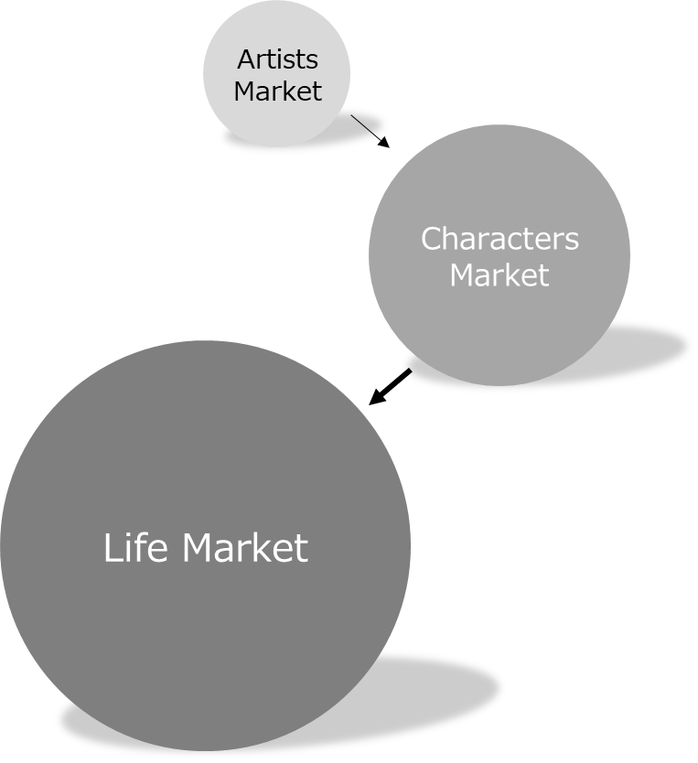

Indie artist stands the priority market among artist market. So far there no such an existing market embedding oligopolistic or exclusive services equivalent to Rights. The earliest goal is to acquire more than 10,000 market users and maintain the business in stable. The next step would be gaining more artists, including big artists. Once famous artists enroll, Rights attains breakthrough.

Addition to above-mentioned Japanese organic growth. We are aiming for in-organic growth overseas as our initial goal. In parallel, we are conducting foremost preparations for Character and Consumer markets for further growth. In principle, after identifying areas where no oligopolistic and monopolistic services are, setting initial target. After that, we will get famous intellectual property holders.

This is the basis growth scenario of Rights.

## Section 2: Organic Growth Measure

This section demonstrates domestic growth strategy (= organic growth strategy). With the artist market as an example. Domestic growth includes 2 steps:

**Step ①　Acquiring initial customer by creating non-competition market**

First step: Attracting artists and their fans to network through following service measures:

* Regularly holding 「Rights Live」 providing time and location for live performances to acquire Indie idol participation.
* Revitalizing market through comprehensive large-scale event, extending beyond individual artist boundaries (top artist selection, live performance battle etc.)
* Indie idols as center, digital assets be sold in distributed digital network.
* Indie idols as center, offering 「support screening」, a new type of communication service.
* Others: selling digital assets of semi-pro artists, amateur artists
* Pursuing application usability, high evaluation from users (quick responses, no advertising)
* Liberalizing user communication to the utmost (present, sales, remittance, chat function)

**Step ②　Advance into existing large market**

* After a certain number of users acquisition at Step①, attaining major production artists
* Prioritizing brand new artists produced by major production（potential future stars）
* Meeting requirement specialized to major artists（service extension）
* Based on major production artist participants, aiming for further acquisition of major artists

Rights continue to grow as a network by above steps/ measure.

## Section 3: In-Organic Growth Policy

As mentioned in section 2, a quick implementation like early footholds and subsequent expansion plays an essential role. At the same time, special business development that brings high growth is vital to any type of business. This section refers to approaching method to Rights abroad market.

As mentioned in Chapter 2, Asia-Pacific market is one of the most remarkable growth markets past and future. Therefore, Asia-Pacific entry is currently Rights strategic key to reach out global market.

**Asia-Pacific market expansion**

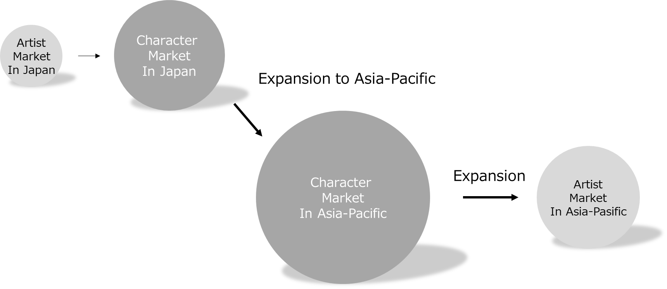

To penetrate into Asia market, 「Character market」 is set as the initial theme, attributed to the fact that Japanese contents are highly evaluated over entire Asia Pacific market. Anime and Vide game Characters would be more suitable rather than Japanese artists.

The other side, to expand artist market of each country, spreading horizontally when the entry into the character market succeeds, attaining local artist, move to execution.

By this way, Rights would achieve dramatic growth

## Section 4: Risks And Challenges

To bring the previous scenarios into practice. Main issues and potential risks of Rights are identified as follow:

* Shortage of contents traded on RDDN (issue)  
  Addressing this issue by implementing each measure described in section 2 this Chapter and using SNS… to create movement.
* System performance shortage, defect（risk）  
  As many novelty technologies integrated in Rights such as Blockchain. It is necessary to select the most appreciate one, secure technicians and sufficiently provide test period.
* Customer assets, data lost/leaked (risk)  
  Rights develop team has working along with cybersecurity experts for entire system structure and organizations. From the beginning of service, each step will be solved individually.
* Develop fund shortage (risk)  
  Until RDDN actual earn revenue, it is essential to secure development fund, utilizing all means of token sale, investment etc.

# **Chapter 5 System Roadmap**

## Section 1: Rights Distributed Digital Network Development Schedule

Rights main infrastructure system contains Enterprise Ethereum Quorum, IPFS (Inter Planetary File System) and Latest Language & Implementation (TypeScript, GraphQL and Flux) . Technical adoption criteria prioritize policy giving most suitable actual services including usability, system performance, security.

System development plan of RDDN:

* Whitepaper, Testnet for artist market launching in July 2018.  
  （initially closed test）
* Token sale starts in October 2018, token exchange planned in Spring 2019
* Artist market launching in Spring 2019.  
  According to token sale and service launch, contract code to be released as open source (resemble to other subsequent markets). At early stage, node operators will not reach distribution sufficiently. But increasing node operator number and network growth are expected.
* Character market service launching in Winter 2019.
* Consumer services launching after 2020.

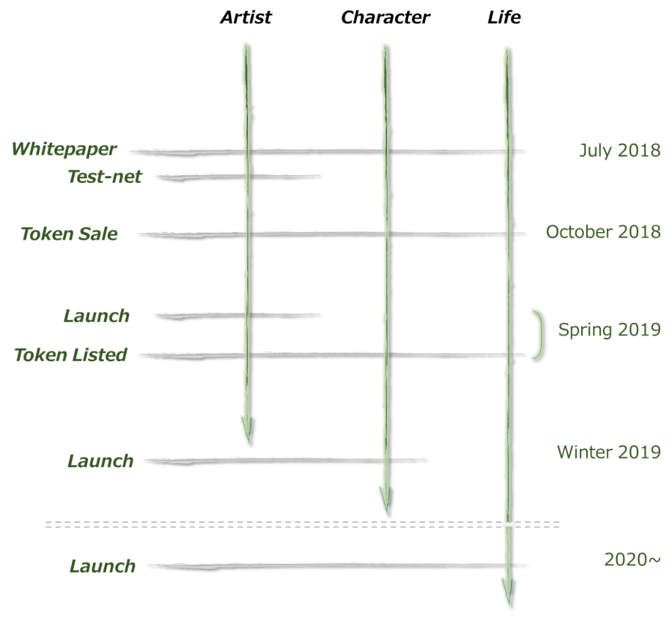

# **Chapter 6 Team**

## Section 1 :Developing Team Introduction

Members participating in RDDN develop program:

|  |  |
| --- | --- |
|  | CEO  Machi　Koji |
| Experiencing over 10 years of IT consulting in Accenture. Decided to establish a Blockchain venture company after BayCurrent Consulting of Japanese companies. In charge of planning, strategic planning. |
| C:\Users\KOJIMA~1\AppData\Local\Temp\IMG_20180607_160133.jpg | CTO  Ohtake Yutaka |
| Over 15 years experiencing system design and project management. Speaker at many Blockchain technician meetups. Designing Rights life cycle from development to system operation. |
|  | Product Manager  Ishikawa Daiki |
| Waseda university based. Fascinated by possibilities of Blockchain after joining a specialized energy company as salesperson. In charge of implementing Rights business strategies. |
|  | Lead Developer  Tanaka Akihiro |
| Web&Mobile development specializer, managing, designing and developing numerous services. Experiencing Blockchain related architecture, SmartContract since 2013. In charge of Rights application design and implementation. |
|  | Global Marketing & PR Leader  Kusuda Kaori |
| Started EC fashion business. Afterwards, experiencing company management with foreign-affiliated brand sales/ IT venture etc.,  Rights Marketing PR team supervision |

|  |  |
| --- | --- |
|  |  |
|  | Global Marketing & PR  Tran Thi Thu Thao |
| Vietnamese Foreign Trade University based. Joining Rights project after having experienced Japanese/ English translation in IT section etc. In charge of Global Alliance |
|  | Engineer/ Idol Industry Advisor  Takahashi Takuya |
| Establishing a Blockchain related venture, in charge of application planning, developing. Joining Rights project since 2018.  Strongly impressed by the CM of Matsuura Aya in Junior high school 1st grade, running idol fans until now. |
|  | Idol Industry Advisor  Ippongi Hiroyuki |
| Founded a music production company in 2001. Currently works as event creator, artist producer, consulting etc. In addition, composing lyrics, arranging, composing guitar band performance. |
|  | Idol Industry Advisor  Minegishi Notof |
| Launching the Tokyo Idol Theater, an idol regular performance event in 2015. The scale is still expanding now.  2017 Girls unit "Girls Live Project" started. In the same year October TOGEKI Corporation established" |
|  | Entertainment Industry Advisor  Hamaguchi Takahiro |
| Director of SPROX Inc., a sales promotion and advertising agency  Vice president New Staff Production Inc., a entertainment business  Following the experiences of music activities, composers, roadie, he started a promotional business in the music industry.  In addition, he supervised the delivery department of food service companies and succeeded in launching many stores. |

|  |  |
| --- | --- |
|  |  |
|  | Business Strategy Advisor  Saito Toshikatsu |
| Having experienced with Sony’s entire entertainment business (movie, music, game) more than 20 years. After leaving SONY, advisor of numerous companies. Currently President of Professional Adviser Association, President & CEO of Steam Inc. Author of the book “How to change your career into your money”. Advising partner of Rights for guiding necessary measures |
| http://www.it-career.or.jp/wp/wp-content/uploads/2017/02/taira-224x224.png | Security Strategy Advisor  Taira Masato |
| Having experienced product specialist of antivirus software.  Achieved White hacker certification “Certified Ethical Hacker” in  2014. Working as a cyber security advisor of central ministry, large  companies. Founded eGIS Co., ltd in 2016.  Rights security strategy planning. |
|  | ICO Advisor  Tsurusaki　Hiroshi |
| CEO of Tekotech inc.  Established Tokyo Bitcoin Exchange(TBE) Inc. and registered as a Virtual currency exchangers. Later, TBE sold to DMMFX HD  In ICO support service provided by Tecotech, they support in all processes from advising ICO process to technical aid |
| ãè¥¿æ ç¥¥ä¸ãã®ç»åæ¤ç´¢çµæ | Technical Adviser  Nishimura　Shoichi |
| Comps ITL Pte. Ltd. CEO Engaged in development and consulting of academic projects such as blockchain technology and natural language processing / machine learning. Awarded the Best Innovation Award by proposing a location information platform based on blockchain in Global Blockchain Summit 2016 |
|  | Legal Adviser  Kawasaki Kenichiro |
| Lawyer,　 Representative of Waseda Legal Commons Law Firm  Supported many projects in the field of blockchains and smartcontracts  He himself launched the Centaurus Works Inc. and is working on the implementation of Smartcontract in the field of Legaltech |
|  | Legal Adviser  Saegusa Mitsuru |
| Wide range of roles as a legal consultant, including participating in business plans and management plans, beyond the framework of corporate legal advisory.  Utilizing the former game planner and career, knowledge of IT related affairs is deep. In recent years he has practical experience in the field of actively working on block chains, virtual currency, AI related affairs |
|  | Designer  Ryu Takahashi |
| After working as a UI / UX designer in mainly the mobile game industry, learned programming in Canada, currently has developed numerous projects as a freelance web designer. In charge of website development, of RIGHTS official site and application design. |

# **Chapter 7: Conclusion**

As explained in previous chapter about business relating RDDN through various viewpoints. This chapter refers to Rights feasibilities and attractiveness.

Rights currently specializing services and deeply exploiting use case towards Indie artist. Despite planning to target multiple markets in the future, the reason behind focusing on a specific area and develop as initial stage is everyone able to know in case they search the key word 「Small Start」, as a proven way of launching 「Small Start」 business.

Rights develop team believe that 「system which available for anything are almost equal to system that unavailable for anything」 At early step of creating system/ services that commonly applicable for numerous use cases, our team was facing challenges to create an actual sufficient system for a specific use case. Hence, our team spent nearly 1 year to refine the use cases.

**Blockchain is hot. However, it’s the mechanism behind business**

That Blockchain itself can not create new attractive services by alone. For instance, creation of user interface of Web-front has direct relation with user satisfaction. A dedicated distribution server to use media information (images, sounds, videos) is required, which has a great impact on expressive power.

Moreover, gadgets and communication environment likewise smartphone and VR are evolving quickly, claiming for many trials and errors to make full use of these functions.

Globally, many technologies are currently under researches, developments. And the way to utilize them in daily life or work place are continuously advancing via trials and errors. For those, business and service developers should keep in mind rather than business and services they want to create, what users need in community should be at heart of their works.

Much as been found about Blockchain excellent possibilities in anti-tampering, decentralized processing, incentive model in crypto-currencies. Real social affects must be brought under objective judgement.

**Use case selection**

3 use cases presented in this paper are filled with possibilities which Rights project team has repeatedly discussed with many industry stakeholders.

To the end points of many discussion. In addition to superficially accessible information such as 「Great market potential」, 「It is industry problem」, we notice that 「we get a never-before-seen despite the actual needs」 and 「able to get service providers and collaborators with enthusiasm for services implementation」 are essential for use cases selections. These factors still play great affects in achieving feasibility and driving force.

For above reasons, Rights as “New Dimension Media Market” creates new services with digital and virtual space for 「Artist」, 「Character」 and 「Consumer」 without competing with existing services.

We strongly hope that any reader about Rights via this paper have sympathies with this project and become our supporters/collaborators.

2018 July 30th

Rights CEO　Machi Koji

Rights Product Manager　Ishikawa Daiki

# Change History

July 30, 2018 First edition

September 18, 2018 1.01 edition Partial revision of Chapters 2, 3, 5 and 6

October 11, 2018 1.02 edition Update Logo, Chapter 6 and 7

October 16, 2018 1.03 edition Remove Chapter7